Week 5: Payment Transaction Management System

The e-commerce company needs to maintain payment information for customer orders. The system should record payment details, track transaction status, manage successful and failed payments, and generate payment-related business reports. Students will create a Payment Transaction Module connected with the existing Customer and Order Management modules.

Payment Table:
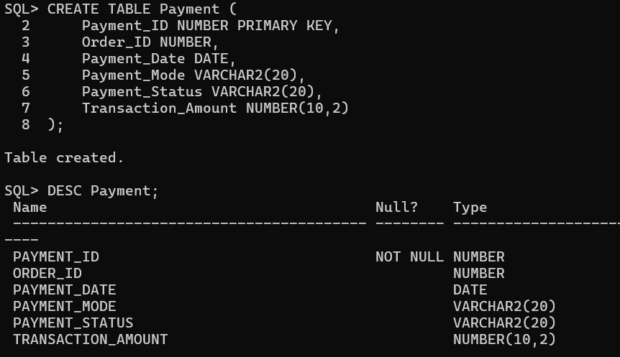
Add Foreign Key
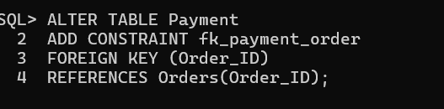
NOT NULL constraints
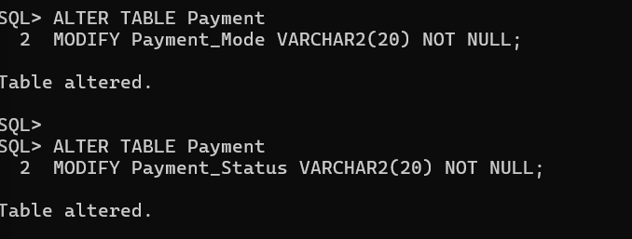
CHECK constraint

Manage Successful and Failed Transactions Tasks:

1. Display all successful payments.

2. Find failed transactions.

3. Count total successful and failed payments

Display all successful payments
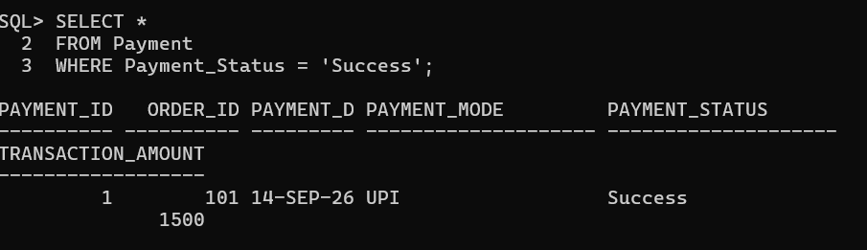
Find failed transactions
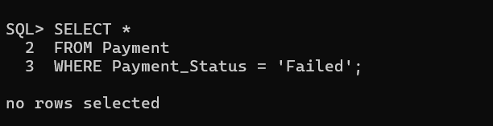

Count total successful and failed payments
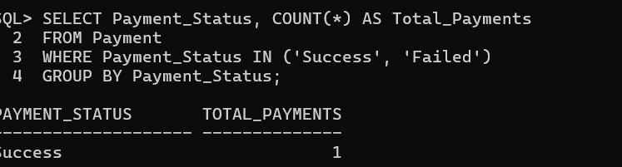

Update failed payment after retry
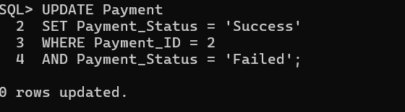
Identify pending transactions
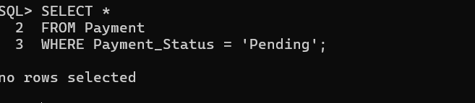

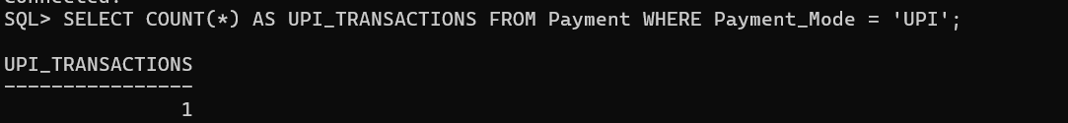

Payment Analysis:
